In this post we’d like to introduce you to our new R package shinyMatrix. It provides you with an editable matrix input field for shiny apps.

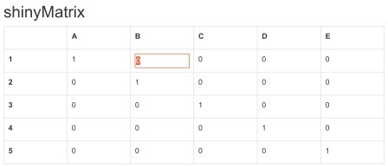

# Use Cases for Matrices in Shiny

We have been developing shiny apps for quite some years now. A problem we stumbled upon multiple times in this process was, that there is no easy approach to define matrices in shiny. So we had to help ourselves with workarounds. The use cases for matrices are obvious, though:

Definition of covariance matrices

Entry or modification of smaller data sets by hand Define contrasts for a statistical model

etc.

# Alternatives to shinyMatrix

As mentioned we had to find some workarounds in the beginning. Either one could define a text field (textAreaInput), which then can be transformed into a matrix. Or one could create multiple input fields dynamically in R via renderUI and bring these fields together afterwards. It’s laborious, but it works. The package DT offers the possibility to edit cells in a data frame. But to use this to input a complete matrix, it is laborious too, and second one has to implement the changes to the data set also on the server side. That’s what drove us to build a package for easy matrix input in shiny.

# shinyMatrix Features

The current version 0.3.0 of shinyMatrix on CRAN comes with the following features:

ui function to define a matrixInput field

use the matrix via input$elementId – hence no transformation, parsing, etc. needed copy’n’paste: within the app and between the app and a table calculation program usage of “tab” and “enter” in order to jump from one matrix cell to another automatic size adjustment of the matrix

editable matrix row and column names serverside update of matrix via updateMatrixInput

automatic transformation of the matrix into the correct class (currently “character” and “numeric” are implemented

# Usage

We created a very simple example app to demonstrate the shinyMatrix package

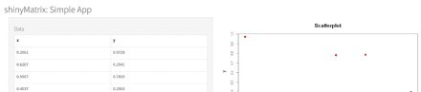



For reasons of simplicity we use a single file app.R for the app. It contains as always a server and an ui function

## app.R library("shiny") library("shinyMatrix") m <- matrix(runif(12), 6, 2, dimnames = list(NULL, c("x", "y"))) ui <- fluidPage( titlePanel("shinyMatrix: Simple App"), sidebarPanel( width = 6, tags$h4("Data"),

matrixInput( "sample", value = m, rows = list( extend

= TRUE ), cols = list( names = TRUE ) ) ), mainPanel( width = 6, plotOutput("scatter") ) ) server <- function(input, output, session) { output$scatter <- renderPlot({ plot(input$sample, col = "red", main = "Scatterplot") }) } shinyApp(ui, server)

Via the parameters of the matrixInput function one can configure the input field. In this example we use:

sample: ID of the input field value: initial matrix (optional)

rows.extend: add rows automatically (optional) cols.names: show column names (optional)